OUTLINE AND BRIEF INSTRUCTIONS

- You may access the Unit/Program review application locally by going directly to http://10.39.9.16/PRver1.aspx
You may also access the site through the sharepoint application:
locally, by typing lmcsharepoint into the address bar of your internet browser, or
remotely, by logging into http://remote.losmedanos.edu and clicking on the sharepoint link.
Once in sharepoint, click on the “program/unit review” tab. The application can be launched by clicking on the “Program Review Application” icon on the right hand side of your screen.

- General Instructions: When you access the site the following instructions page will appear:

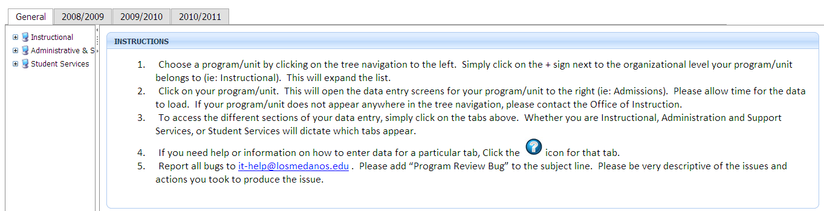
Navigate to your program by expanding the categories on the left and clicking on your program.

- Example Unit/Program “General Page” page: You can see the “tabs” at the top of each page. Instructional CTE units/programs include a Core Indicator tab. Instructional and Student Service units/programs include the PSLO/Assessment tab. Contained in this tab are links to the documentation for PSLO assessment. Once a PSLO assessment document has been completed, it should be saved to the appropriate location on the P: drive (see instructions below). The Documents tab is where unit/program data is located along with a link to the comprehensive ARCC report website. On the General page is a short unit/program description and a brief mission statement. The mission statement should align with and support the college mission. If your unit/program has not completed a description and/or a mission statement, you need to do so. If you have a website for your unit/program, enter the URL and please indicate when your site was last updated.
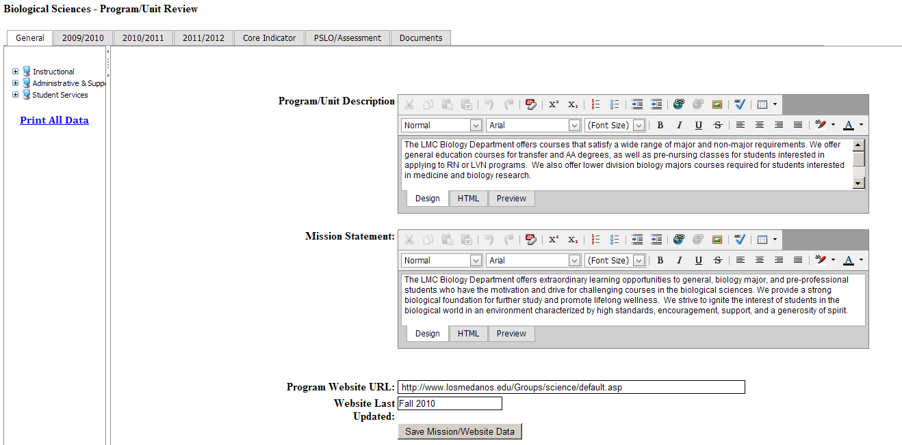

You should update your unit/program members by either editing existing members, adding new members, or deleting old members.
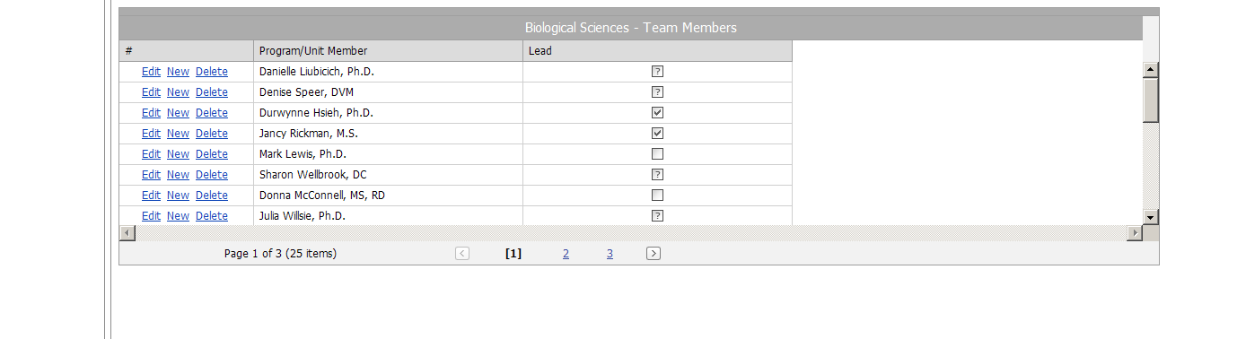
- As in the past we have three years of review, assessment and planning to address. You can access your unit/program data by clicking on “Documents”. Trends in seat count, retention & success rates and observations/recommendations have been provided by the Office of Institutional Research along with a link to the most current ARCC data. Click on the 2009/2010 tab. Below is an example. Notice there are no narrow columns! You can even widen these by clicking on the lines separating the columns. Units/programs should update the status and status reason by clicking on “Edit”. They should also update the “Program Improvements” column indicating what improvements were made to the unit/program by the attainment of the objectives. Remember, we are at the sustainable, continuous quality improvement level!

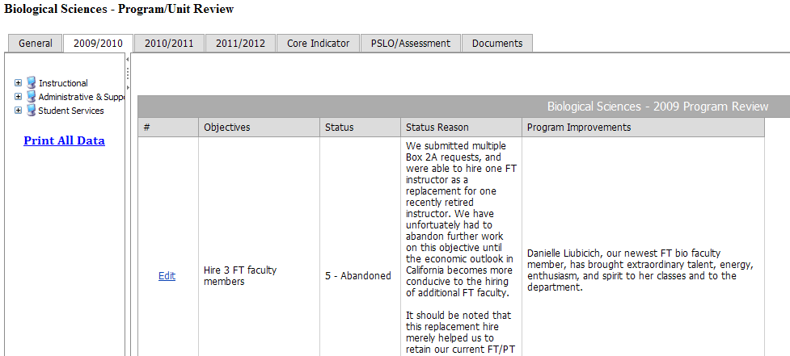

- 2010/2011 Progress Report: Click on the “2010/2011” tab. The objectives you developed last Fall should appear. Please report the status and reason for status. If your program has experienced improvements based on achievement of the objective, please indicate what those improvements are in the last column. If it is too early, you will have an opportunity to reflect on this, have a unit/program dialogue, and report improvements next year.

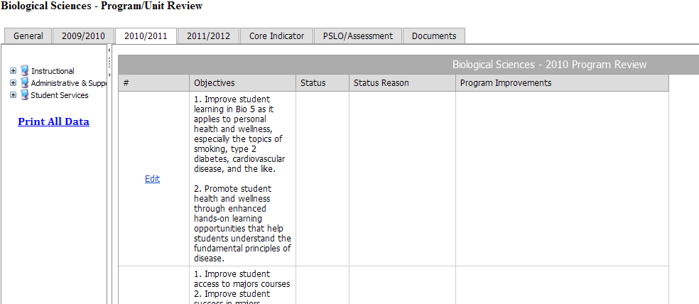

- New Fall 2011 Planning Objectives. Below is the template for developing objectives and plans for this year. By clicking on “New” for each new objective, you will get the page below this one. Click in each box to input the information and click on “Update” in the lower right-hand corner to save any information.
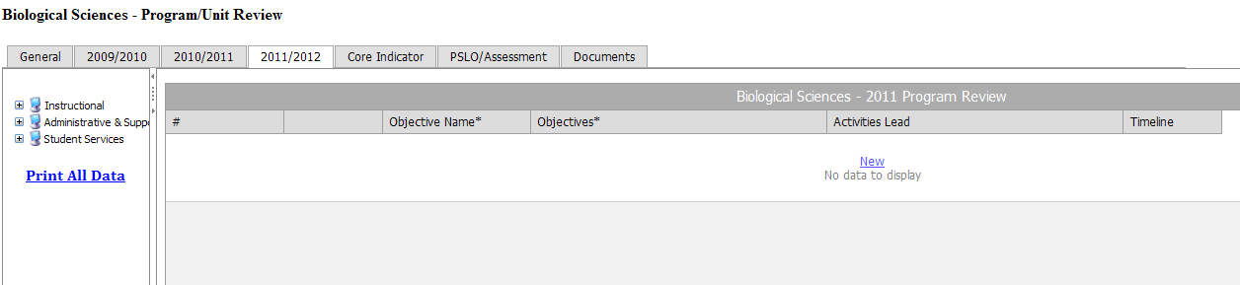
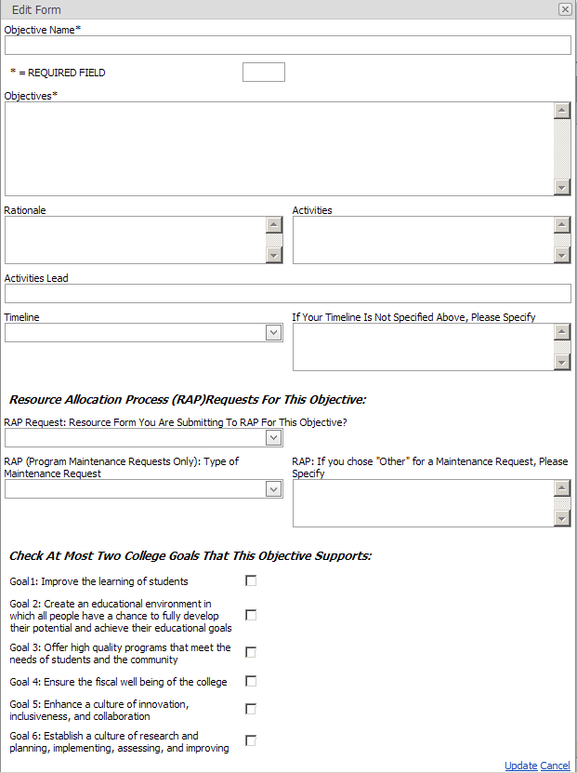
- Core Indicator Section: CTE units/programs are to complete this section a part of which is shown below:
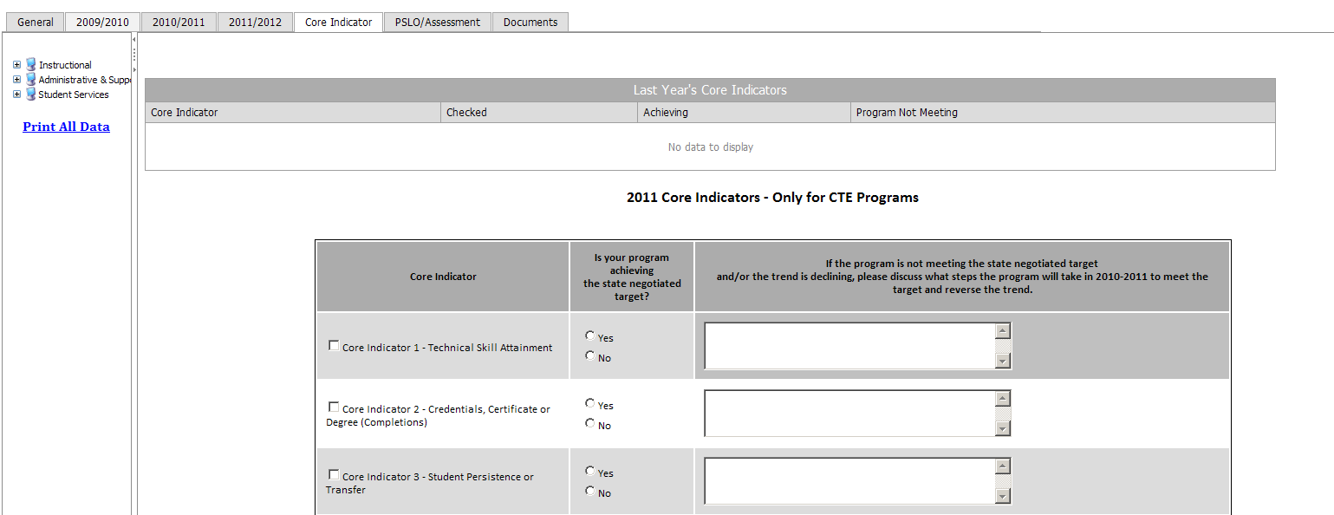

- PSLO/Assessment. This section separates programs from units. The Teaching and Learning Project has recently determined that for the purposes of assessment, a program at LMC shall be defined as:

- A program of study leading to a degree
- A program of study leading to a state-approved certificate
- An organized service or sequence of courses leading to a defined objective

Units that don’t satisfy this definition are not required to establish and assess PSLOs (Student Learning Outcomes are probably not appropriate for units) and may wish to remove any PSLOs they developed in the past. Student Service programs, ESL and Developmental Math and English are examples of an “organized service or sequence of courses leading to a defined objective.

Programs: If you have not already done so, you are required to complete a PSLO assessment by the beginning of Fall 2012. In this section you are to complete the “Teaching and Learning Project Assessment Report” as outlined below (Mac users: You can access the P drive by using remote.losmedanos.edu):

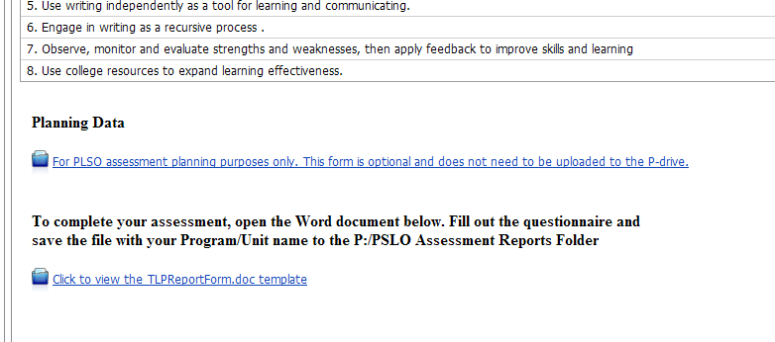

- Feedback on the Fall 2011 Unit/Program Review, Assessment and Planning

Feedback on the design, template, and process will be gathered through a survey that can be accessed by clicking on the link located on the left hand side of the program review application (see below). You need to leave feedback on the process upon the completion of your updates and creation of your new objectives.
